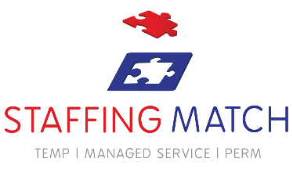
Day Team


Sabah Sehgal
Leicester
Sabah Sehgal Staffing Match is the best! #staffingmatch

Sabah Sehgal
Leicester
Sabah Sehgal Staffing Match is the best! #staffingmatch

Sabah Sehgal
Leicester
Sabah Sehgal Staffing Match is the best! #staffingmatch

www.staffingmatch.co.uk

