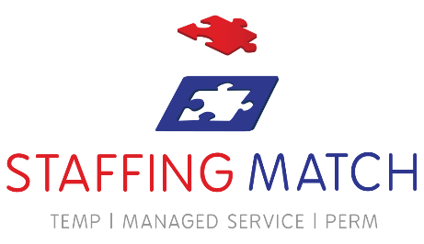
Photo Consent Form

First Name:
Last Name:

I am of legal age (18+): Yes No

I (Name above) hereby give my consent to Staffing Match to use my photograph for marketing and advertising purposes. For potential use on their website, social media site and/or marketing collateral.
In giving this consent, I understand and declare that:

- I am giving this consent in my own free will, and not under duress or in any form of threat;

- That the images containing the subject in this consent shall be held by Staffing Match in accordance and compliance with the GDPR guidelines (the General Data Protection Regulation);

- That my information herein, as well as the images to be shared to any other party without my written consent;

- I may exercise my right to withdraw the use of my image anytime after from the effectivity of this consent.

Signature: Name Printed:

Date:
www.staffingmatch.co.uk

