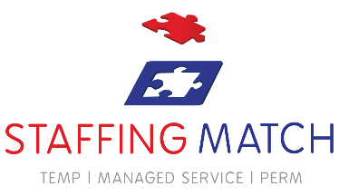
Employee of the Month – February
Congratulations


Sabah Sehgal
Leicester
Sabah Sehgal Staffing Match is the best! #staffingmatch

Place picture here
<Enter your content, and what they have won>

www.staffingmatch.co.uk

